
WEB ENG.
Major Assignmnet

May 12, 2025
13964
Rahimeen Shafiq

Digital Notice Board Application Documentation

1. Introduction
This document provides a basic overview and technical details of the digital notice board application. The application allows administrators to post, update, and delete notices and manage users, while regular users can only view the posted notices.

2. Technologies Used
- Frontend:
  - HTML: For structuring the web pages.
  - CSS: Styled using Bootstrap for responsiveness and basic aesthetics.
  - JavaScript: For interactive elements and modal functionality.
- Backend:
  - PHP: For server-side logic and database interaction.
- Database:
  - MySQL: For storing notices and user information.

3. Database Structure
The application utilizes a MySQL database named noticeboard with the following tables:

3.1 notices Table
Column | Data Type | Attributes | Description
notice_id | INT(11) UNSIGNED | AUTO_INCREMENT, PRIMARY KEY | Unique identifier for each notice.
title | VARCHAR(255) | NOT NULL | Title of the notice.
description | TEXT | NOT NULL | Detailed content of the notice.
created_at | TIMESTAMP | DEFAULT CURRENT_TIMESTAMP | Timestamp when the notice was created.
updated_at | TIMESTAMP | DEFAULT CURRENT_TIMESTAMP ON UPDATE CURRENT_TIMESTAMP | Timestamp when the notice was last updated.

3.2 users Table
Column | Data Type | Attributes | Description
user_id | INT(11) UNSIGNED | AUTO_INCREMENT, PRIMARY KEY | Unique identifier for each user.
username | VARCHAR(50) | UNIQUE, NOT NULL | Unique username for login.
password | VARCHAR(255) | NOT NULL | Hashed password for authentication.
role | ENUM('admin', 'user') | NOT NULL, DEFAULT 'user' | User role (either 'admin' or 'user').
created_at | TIMESTAMP | DEFAULT CURRENT_TIMESTAMP | Timestamp when the user account was created.

4. File Structure
The application consists of the following PHP files:
- index.php: The main page for regular users to view notices.
- admin_dashboard.php: The dashboard for administrators to manage notices and users.
- process_notice.php: Handles the creation, updating, and deletion of notices.
- process_user.php: Handles the creation, updating, and deletion of user accounts.
- login.php: The login form for both administrators and regular users.
- process_login.php: Handles the authentication of users and redirects them based on their role.
- user_dashboard.php: The dashboard for regular users to view notices after logging in.
- logout.php: Handles the process of logging out users by destroying their session.
All these files should be placed in a web-accessible directory on your local server (e.g., htdocs if you are using Apache on localhost).

5. Setup Instructions (Localhost)
- Install XAMPP/WAMP/MAMP: Ensure you have a local web server environment with PHP and MySQL installed.
- Start Apache and MySQL: Start the Apache web server and the MySQL database server.
- Create the Database:
  - Open your MySQL administration tool (e.g., phpMyAdmin accessible via http://localhost/phpmyadmin/).
  - Create a new database named noticeboard.
- Import the SQL Query:
  - Select the noticeboard database.
  - Go to the "SQL" tab.
  - Paste the SQL query provided earlier (in the first response) into the text area and click "Go". This will create the notices and users tables and insert an initial admin user (remember to replace the placeholder password hash).
- Place the PHP Files: Copy all the PHP files (index.php, admin_dashboard.php, process_notice.php, process_user.php, login.php, process_login.php, user_dashboard.php) into the web root directory of your local server (e.g., htdocs within your XAMPP installation).
- Access the Application:
  - To view the main notice board (without login), open http://localhost/index.php in your web browser (replace index.php with the actual directory name if you placed the files in a subdirectory).
  - To access the login page, open http://localhost/login.php.

6. Functionality

6.1 User Dashboard (user_dashboard.php)
- Displays a list of all published notices, ordered by the most recent first.
- Shows the title, description, and creation date of each notice.
- Provides a welcome message (to be enhanced with user-specific information after login implementation).
- Logout: Includes a "Logout" button that redirects the user to logout.php to end their session.
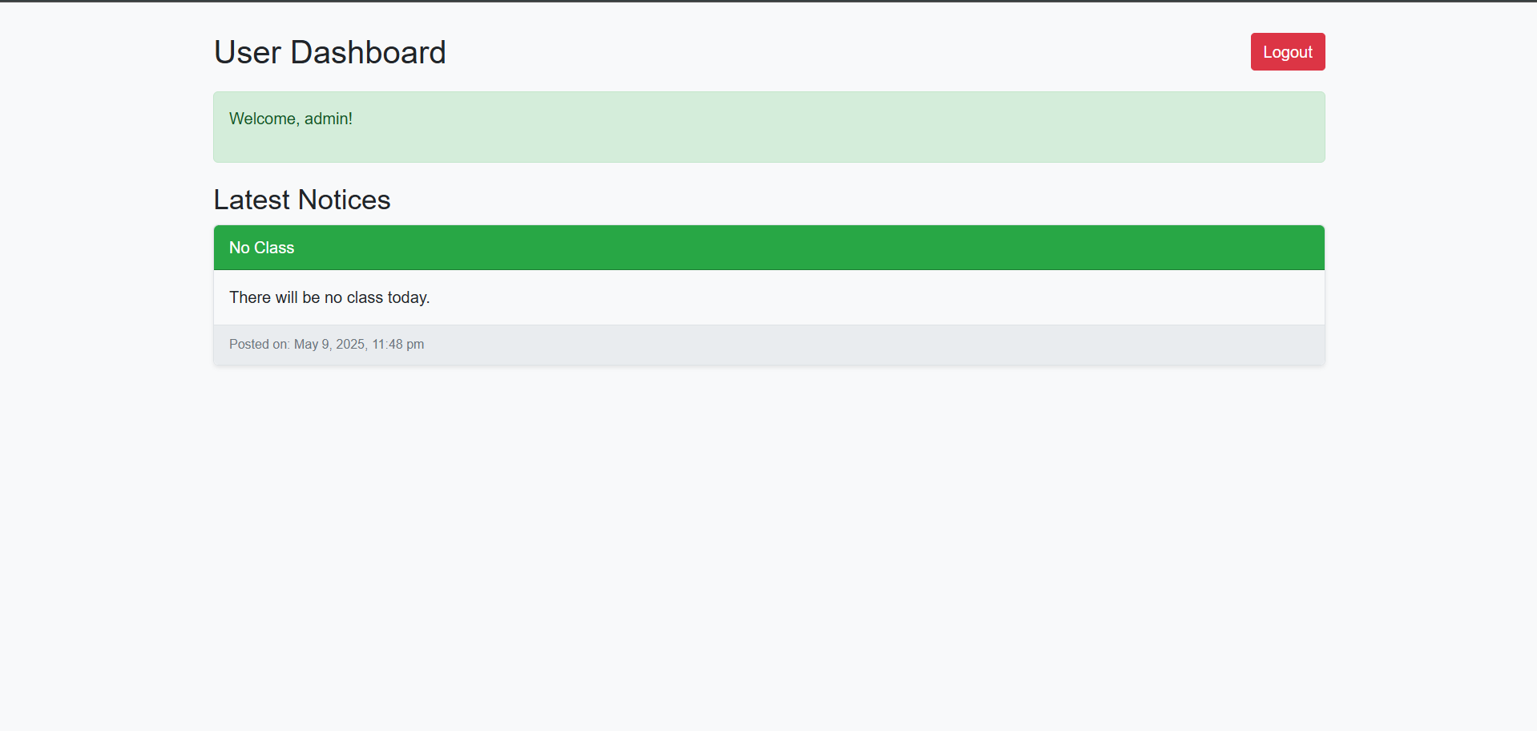

6.2 Admin Dashboard (admin_dashboard.php)
- Provides an interface for managing notices:
  - Add New Notice: Allows administrators to create and publish new notices.
  - Edit Notice: Enables administrators to modify existing notices.
  - Delete Notice: Allows administrators to remove notices.
- Provides an interface for managing users:
  - Add New User: Enables administrators to create new user accounts with specified usernames, passwords, and roles (admin or user).
  - Edit User: Allows administrators to modify existing user roles.
  - Delete User: Enables administrators to remove user accounts.
- Logout: Includes a "Logout" button that redirects the administrator to logout.php to end their session.
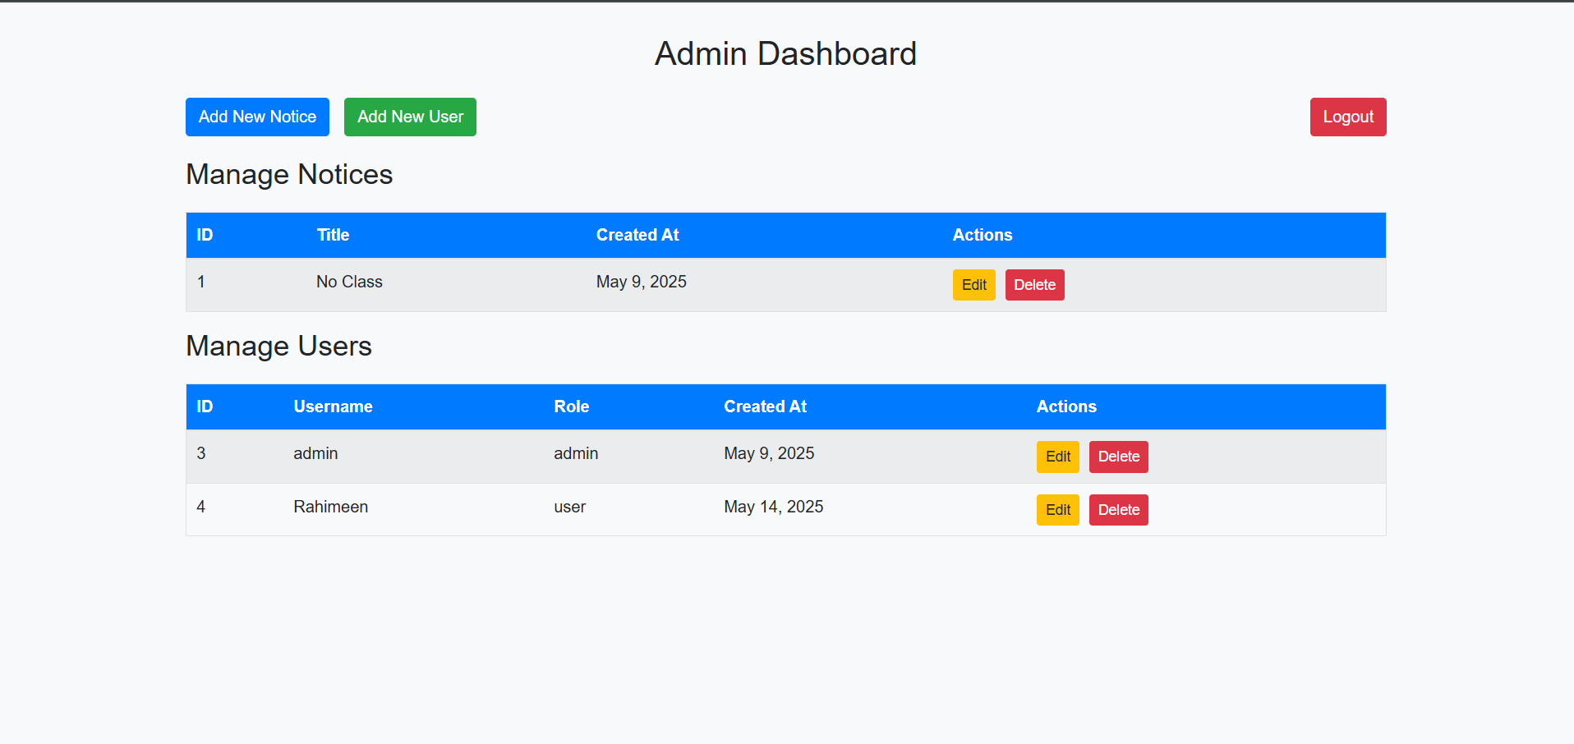

6.3 Login (login.php and process_login.php)
- Provides a login form for users and administrators to enter their username and password.
- Authenticates users against the users table in the database.
- Upon successful login, redirects users to the user_dashboard.php if their role is 'user' and to admin_dashboard.php if their role is 'admin'.
- Displays error messages for incorrect login attempts.
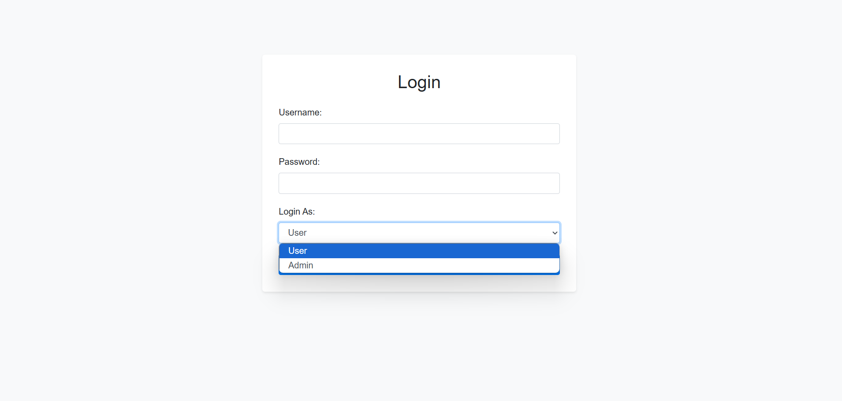

6.4 Notice Management (process_notice.php)
- Handles form submissions from the admin dashboard for adding, editing, and deleting notices.
- Interacts with the notices table in the database to perform these operations.
- Redirects the administrator back to the admin_dashboard.php after each operation.

6.5 User Management (process_user.php)
- Handles form submissions from the admin dashboard for adding, editing, and deleting user accounts.
- Securely hashes passwords before storing them in the users table.
- Interacts with the users table in the database to perform these operations.
- Redirects the administrator back to the admin_dashboard.php after each operation.

6.6 Logout (logout.php)
This script is executed when a user clicks the "Logout" button on either the user or admin dashboard.
- It starts the current session.
- It unsets all session variables.
- It destroys the session.
- Finally, it redirects the user back to the login.php page.
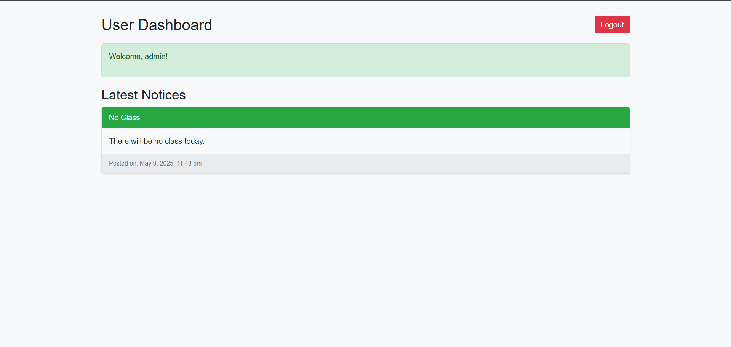

7. Security Considerations (Basic)
- Password Hashing: User passwords are stored in the database using the password_hash() function for security.
- SQL Injection Prevention: User inputs are sanitized using $conn->real_escape_string() to prevent basic SQL injection attacks.
- Authentication: The login system verifies user credentials against the database.
- Session Management: Basic session management is implemented using PHP's session_start(), $_SESSION, and session_destroy(). Ensure that session.cookie_httponly and session.cookie_secure are properly configured in your PHP settings for enhanced security in a production environment.

8. Potential Future Enhancements
- More detailed user profiles.
- User-specific notice viewing (if needed).
- Email notifications for new notices.
- A more visually appealing user interface.

